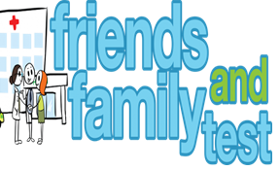
HAVE YOUR SAY TO IMPROVE YOUR CARE!
COMPLETE OUR SHORT QUESTIONNAIRE ON HOW LIKELY YOU ARE TO RECOMMEND OUR SURGERY TO FAMILY AND FRIENDS.
We have been collecting your replies and below are our results for
September 23
Very Good | Good | Neither Good/nor poor | Poor | Very Poor | Don’t Know
27 | 1 | 2 | 0 | 0 | 1

Recent comments:
- Awesome!
- Staff and doctors are fab.
- Always easy to arrange an appointment within a reasonable time.
- Brilliant service.
- Incredibly efficient and friendly.

